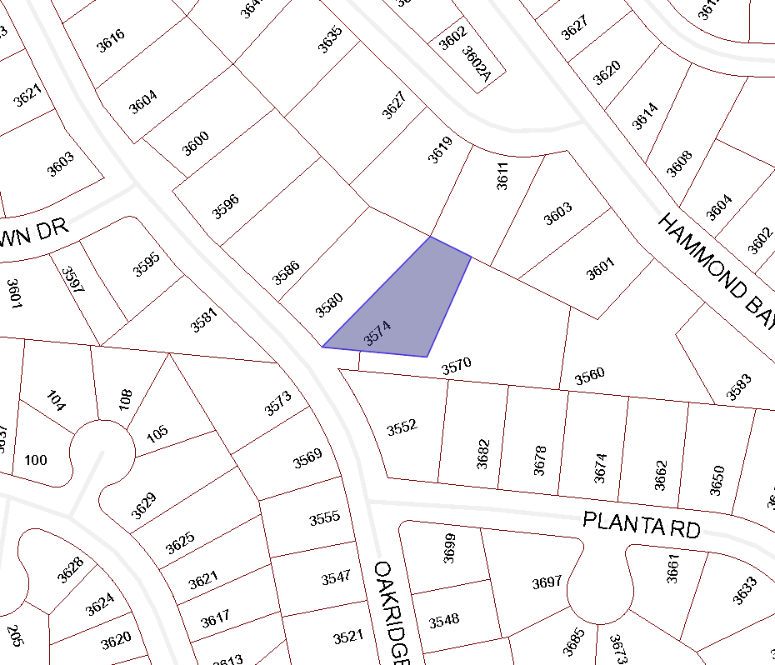

BOARD OF VARIANCE APPLICATION BOV00666

LOCATION MAP

CIVIC: 3574 OAKRIDGE DRIVE

LEGAL: LOT 1, DISTRICT LOT 39, WELLINGTON DISTRICT, PLAN 28415

